Disaster Preparedness Guide
for
Persons with Disabilities
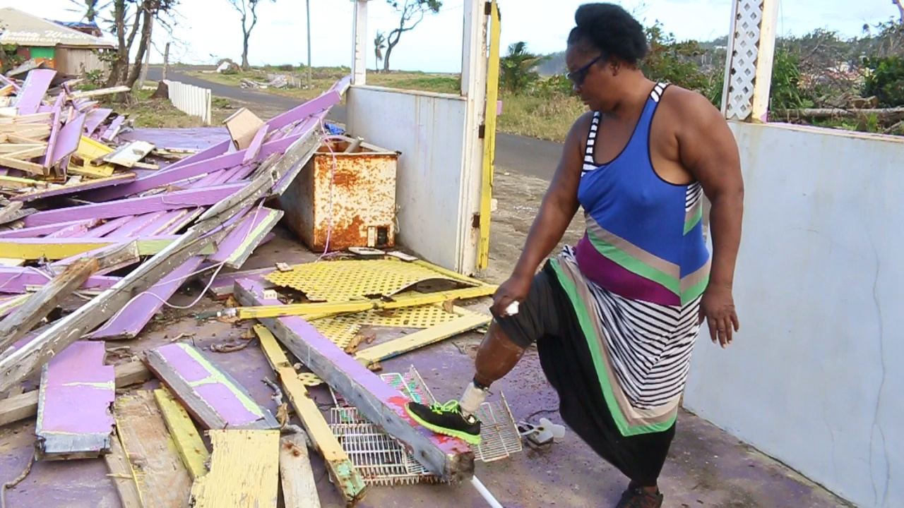

in Dominica

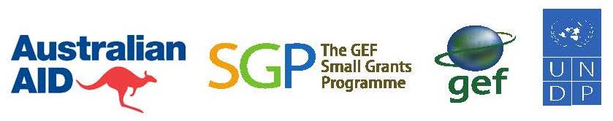

Contents
Definitions 3
Acknowledgements 4
Foreword 5
Overview 7
Hazard Analysis 9
Watches and Warnings 11
General Disaster Awareness 13
PWDs and Disaster-Related Stress 14
The Basic Emergency Kit 16
Preparedness and Response Recommendations 18

Emergency Shelters and PWDs 23

Special Disaster Response Tips for PWDs 25
Appendices 28 - 32

Definitions
Climate | The weather conditions prevailing in an area in general or over a long period
Climate Change | A change of climate which is attributed directly or indirectly to human activity that alters the composition of the global atmosphere and which is in addition to natural climate variability observed over comparable time periods.
Crisis | An event, or perceived event, that has the potential to cause harm to an individual or community, e.g. fire, death or serious injury.
Disaster | An event which results in major injury, fatalities and significant damage to property on a national or regional basis, and which is beyond the capacity of individuals and local authorities to adequately respond to such as major hurricanes, tsunamis, etc.
Disaster Risks Reduction | The systematic development and application of policies, strategies and practices to minimize vulnerabilities and disaster risks throughout a society to prevent and limit negative impacts of hazards.
Hazard | An external risk to a person, object, or system. It could be natural or man-made.
Mitigation | Activities aimed at reducing the impact and effects of an event.
Preparedness | A set of measures and actions aimed at reducing the loss of human life and other damage.
Prevention | Actions aimed at eliminating risk by preventing the event from occurring or preventing damage by avoiding or limiting exposure to the hazard by an individual or community.
PWDs | Persons with Disabilities
Safe Zone | An area which has been identified by appropriate authorities as safe to evacuate to, especially after disasters such as tsunamis, volcanic eruptions or earthquakes.
Threat | An action or event likely to cause damage or danger
Weather | The state of the atmosphere at a particular place and time as regards heat, cloudiness, dryness, sunshine, wind, rain, etc.

Acknowledgments

This document was prepared by Disaster Risk Reduction (DRR) Consultant, Mr. Clement Richards, as part of activities of a DAPD project funded by the Global Environment Facility Small Grants Programme (GEF SGP), entitled "Empowering Persons with Disabilities for Climate Resilience through Capacity Building and Livelihood Support."

In the cover photo a DAPD member proudly shows her prosthetic leg while standing in the wreckage of her Restaurant and Bar after Hurricane Maria in 2017.

Foreword
Dominica is susceptible and vulnerable to hazards and natural disasters and their frequent occurrences make it imperative that its population is always prepared for any eventuality.
Dominica’s exceptional geological, environmental features, mountainous attribute, geographical location and topography, are among the factors for its vulnerability and many citizens are left with no choice but to build homes in areas that are unsafe.
Among sections of the population which get affected by this situation are persons with disabilities.
The Climate Change phenomenon which islands around the world have been grappling with for decades now, has exacerbated the situation and critical measures are now being instituted to mitigate against these hazards.
The Government of the Commonwealth of Dominica has articulated a bold and unparalleled vision to become the world's first Climate Resilient nation and has introduce a Climate Resilient Recovery Plan, with strategies to be adopted to cushion any effects of natural disasters. This is as a direct result of the devastation which the country sustained due to a Category 5 Hurricane, less than three years ago.
One of the realities of this hurricane was the lack of preparation of citizens. This is being eliminated with the organizing of regular Disaster Preparedness programmes. At these forums, it is also being discovered that many lack knowledge on Best Practices for catering to the needs of persons with disabilities.
Against this background, the Dominica Association of Persons with Disabilities is initiating measures to provide those charged with the responsibility of providing safety and protection to that section of the population with knowledge and information through the production of this guidebook.
This will be useful for the Office of Disaster Management, Local Government Authorities, Private Sector bodies, Faith based and Civil Society Organisations, Families and Learning Institutions, Disaster Preparedness Committees, Shelter Managers, Parliamentarians and of course the Government of Dominica.
This is all part of DAPD’s programmes on Climate Change Adaptation, Disaster Risks Reduction and Mitigation as well as, answering to ARTICLE 11 of the United Nations Convention on the Rights of Persons with Disabilities (UN CRPD) which states:
"States parties shall take, in accordance with their obligations under international law, including international humanitarian law and international human rights law, all necessary measures to ensure protection and safety of persons with disabilities in situations of risk, including situations of armed conflict, humanitarian emergencies and the occurrence of natural disasters."
We are grateful to the Global Environment Facility Small Grants Programme (GEF SGP) for funding this publication, Clement Richards for producing this Guide and the printers who provided discounts so that we could have adequate copies for distribution.

Mrs. Nathalie Murphy

Executive Director

Dominica Association of Persons with Disabilities (DAPD)

February 28, 2020

Overview
The impact of Hurricane Maria on Dominica in 2017, clearly demonstrated that Persons with Disabilities (or PWDs) are among the vulnerable groups in our society, and indeed can be described as "among the most vulnerable of the vulnerable". Moreover, notwithstanding best intentions, the official response to this segment of the population following this disastrous event left much to be desired. This conclusion was highlighted in the documentary produced by the Dominica Association of Persons with Disabilities (DAPD) Inc. in April of 2018 entitled "Natural Disasters and Persons with Disabilities: The Hurricane Maria Experience In Dominica."
The film focused on the lack of appropriate support and assistance experienced by DAPD members immediately after the hurricane through a series of traumatic personal testimonies, and proposed a series of measures which could remedy this situation in the future. The documentary highlighted some of the important lessons that the disability community in Dominica learned from the experience of Hurricane Maria, including the following:
i) Persons with Disabilities should prepare Personal Disaster Plans relating to their specific situation

ii) Relevant authorities should prepare special programs for responding to the needs of Persons with Disabilities during periods of disaster

iii) Persons with Disabilities wishing to do so should be taken to appropriate shelters or places of safety well in advance of a disaster

iv) Emergency shelters should be accessible and appropriate to the needs and requirements of Persons with Disabilities

v) Priority attention should be given to Persons with Disabilities after a disaster since they are among the most vulnerable

The documentary is available for review at the Media Vault of the DAPD website, at the following internet address:https://dapd.weebly.com/media-vault.html.
This Disaster Preparedness Guide for Persons with Disabilities in Dominica is therefore part of the response to the issues raised in the documentary and subsequent post-Maria workshops and events held by the DAPD. This is part of a proactive response strategy which seeks to ensure that PWDs in Dominica – both members and non-members of DAPD – are informed of ways to prepare for and respond to natural disasters. Also, that national authorities should pay particular attention to the needs and issues of the disability community during national emergencies.
However, it is not possible to prepare a master disaster plan which responds to the specific physical and environment conditions of every individual with a disability on island. PWDs in Dominica should therefore use this guide as an information source for preparing individual Disaster Plans and response strategies suited to their particular needs and conditions.
These plans should ideally be prepared with support of a Personal Network and shared with Village Councils, Disaster Committees, Community Emergency Response Teams, and other related organisations.
A Personal Support Network is a vital component of an appropriate disaster preparedness and response strategy for PWDS. This network is usually comprised of family members, neighbours, friends, and other persons who are committed, and give priority attention, to the task of assisting PWDs before, during, and after a disaster or major crisis. It is highly recommended that all PWDs in Dominica attempt to develop an effective personal support network where they do not exist, or strengthen those which are present. Appendix 1 shows a Contact Form for members of a Personal Support Network
It is anticipated that organisations related to disaster preparedness such as the Office for Disaster Management (ODM), the Community Development Division, the Dominica Red Cross, local and international NGOs, etc., will incorporate some of the ideas and suggestions contained in this guide within their own plans and programs.

Hazard Analysis
According to diverse sources, Dominica is vulnerable to a wide range of natural hazards, with the most common and historically most significant being tropical storms and hurricanes. Other significant hazards with a moderate to low probability of impact include:
Floods
Landslides
Volcanoes
Earthquakes
Tsunamis
Floods and landslides usually accompany severe weather systems, but sometimes results from relatively mild weather systems, such as after periods of heavy, or prolonged, rainfall. However both of these events sometimes occur even during periods of sunshine, or “good weather”.
Bush and home fire are other potentially serious hazards, especially for persons in the disability community.
However, since this guide is concerned with major disasters or emergency situations, the focus will be on hurricanes, volcanic eruptions, earthquakes and tsunamis. Among the anticipated impact from these major hazards are the following:
Hurricane Considerations
Vulnerable areas:
The entire country, specifically the coastal communities
Vulnerable Elements: human resource, infrastructure, communication/utilities,
Marine ecosystem (coral reef), agriculture, ports
Earthquake and Tsunami Considerations
Vulnerable areas:
Communities along the West Coast (Scots Head to Capuchin)
Roseau and Portsmouth – densely populated, infrastructure
Vulnerable Elements: human resource, infrastructure, communication/utilities,
Marine ecosystem (coral reef), agriculture, ports
Volcanic Considerations
Vulnerable Areas
North: Morne Au Diable (MV): Penville – Pointe Round
South: Morne Plat Pay (MV#1): Roseau – Scotts Head
Vulnerable Elements
Eco systems, Bio-diversity,
Human: Elderly and Children (0-18 years), respiratory disorders
Major infrastructures: Prisons, Government building, Public Health
Air traffic: Canefield and Marigot
Food and Water safety (reservoir)
Road networks
Electricity supplies (utilities)
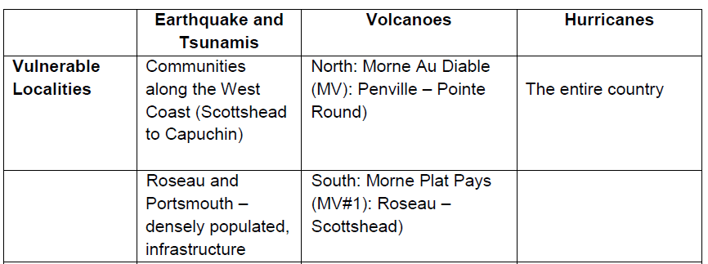
(Source: Disaster Risk Reduction Country Profile, Dominica 2014)

Watches and Warnings
As can be seen from the preceding, hurricanes and other forms of extreme weather are not the only potential disaster confronting Dominica, but they are however the most frequent and probable.
The Dominica Meteorological Service gives information to the public about severe weather events such as hurricanes, floods, and sea swells, and often uses the words "watch" and "warnings" when doing so. To assist those who may be unsure as to the meaning of these words we present the following explanation:
1) Watch
A “watch” means that severe weather is threatening and may occur in your area. Listen closely to instructions from local officials on TV, radio, cell phones or computers and evacuate if told to do so.
Storm Surge Watch: There is a possibility of life-threatening inundation from rising water moving inland from the shoreline somewhere within the specified area, generally within 48 hours.

Tropical Storm Watch
Tropical storm conditions (sustained winds of 39 to 73 mph) are possible within the specified area within 48 hours.
Hurricane Watch: Hurricane conditions (sustained winds of 74 mph or greater) are possible within your area. Because it may not be safe to prepare for a hurricane once winds reach tropical storm force, The NHC issues hurricane watches 48 hours before it anticipates tropical storm-force winds.
2) Warning
A “warning” means that the event is happening now; it is imminent or has been seen on weather radar. This is the time to immediately protect yourself.
Storm Surge Warning: There is a danger of life-threatening inundation from rising water moving inland from the shoreline somewhere within the specified area, generally within 36 hours. If you are under a storm surge warning, check for evacuation orders from your local officials.
Tropical Storm Warning: Tropical storm conditions (sustained winds of 39 to 73 mph) are expected within your area within 36 hours.
Hurricane Warning: Hurricane conditions (sustained winds of 74 mph or greater) are expected somewhere within the specified area. NHC issues a hurricane warning 36 hours in advance of tropical storm-force winds to give you time to complete your preparations. All preparations should be complete. Evacuate immediately if so ordered.
Extreme Wind Warning: Extreme sustained winds of a major hurricane (115 mph or greater), usually associated with the eye wall, are expected to begin within an hour. Take immediate shelter in the interior portion of a well-built structure.
Some events happen very quickly, so warnings may not be issued or you may not receive them. It is therefore advisable that PWDs take action such as evacuating to the Emergency Shelters or alternative places of safety during the "watch" period.

General Disaster Awareness
Persons with Disabilities in Dominica should consider what your environment is likely to look like after the potential disasters which you are preparing for. Disasters have many effects some of which are predictable while others are not. PWDs should therefore be aware of the following circumstances:
In disasters that have high winds and during earthquakes, a great deal of shaking may take place. This can break things and scatter debris. Hanging objects, such as plants, mirrors, and pictures, are likely to fall. Books may be flung from bookcases and the bookcases may fall. In your office, file cabinets, computers, and other unsecured items may fall. Acoustical ceiling tiles and all of the dust behind them may drop. Large and heavy furniture, such as couches, chairs, beds, and dressers, may move and block your pathway completely or in part.
- Floods and earthquakes can cause sidewalks and roadways to crack or become impassable. Roads and sidewalks may be covered by mud, water, or debris, so you may not be able to tell where they begin and end. Mud, sand, and other materials may be left behind for long periods. In floods the water may be moving very rapidly which can prevent you from leaving your location.
- There could be so much debris on the streets that it would take weeks to clear it away. This could leave you stranded at home and keep caregivers from reaching you.
- Familiar landmarks you use to help guide you may move or be destroyed, both indoors and out.
- Your home may be destroyed or isolated with severe damages to make it uninhabitable for a long time, or forever.
- Your usual ways of getting groceries, medications, and medical supplies may be disrupted. It may take several days, or even weeks, before stores reopen, so you may not be able to readily replace even basic items like groceries and prescription medications.
- You may have a hard time reaching or getting help from police and fire departments, ambulance services, doctors, hospitals, pharmacies, veterinarians, and other service providers.
- Utilities like electricity, water, gas, phone and internet service may be disrupted for a long time.
As a result, you may not be able to do the following:

- Cook.
- Cool your home with fans or air conditioners.
- Make or receive phone calls to or from your support network
- Light your home. You may have to move or communicate in the dark.
- Receive emergency information from your television or radio.
- Use equipment dependent on power, such as battery chargers, radios, etc.
- Obtain cash from Banks, Credit Unions, Automatic Teller Machine (ATMs)
- Fill vehicles with gas since pumps may not be working.
- Public transportation, as well as the DAPD wheelchair transport service, may not be operating.
- Travel by road may not be possible since these may be damaged or blocked by debris and fallen trees.

PWDs and Disaster-Related Stress
Experiencing a disaster can be overwhelming and the related stress makes many medical conditions worse. Therefore PWDs may experience one or several of the following symptoms as a result:

Psychological | Physical | Thought | Behavioural
- Anxiety; - Irritability,- Restlessness, over excitability  - Depression, moodiness, crying  - Anger, blaming  - Feelings of apathy, diminished interest in usual activities  - Feelings of isolation, detachment, estrangement  - Feelings of guilt about surviving  - Denial or constriction of feelings  - Flashbacks or unwelcome memories of the disaster  - An exaggerated reaction to being startled, or being startled easily  - Recurrent nightmares about the disaster or about other traumatic events  - Inability to fall or stay asleep  - Sleeping excessively | - Headaches;  -- Weakness  - Nausea, upset stomach, etc.  - Muscle soreness  - Hot or cold spells; sweating or chills  - Numbness or tingling in body parts  - Heavy feeling in arms or legs  - Feeling a “lump” in your throat  - Trouble catching your breath; rapid breathing  - Tremors; -  - Increase in allergies, colds, or flu  - Heart palpitations  Chest pains  - Fatigue | - Poor concentration  - Mental confusion  - Slowness of thought  - Inability to express yourself verbally or in writing  - Forgetfulness  - Inability to make judgments and decisions  - Loss of ability to think of alternatives or prioritize tasks | - Hyperactivity  - Outbursts of anger or frequent arguments  - Loss of objectivity  - Withdrawal, social isolation, distancing yourself from others  - Increased use of alcohol, tobacco, or other drugs  - Avoidance of activities or places that remind you of the disaster  - Family problems and/or conflicts with organisations or individuals providing assistance or support

The information provided in the earlier sections of this document indicates some of the factors which PWDs in Dominica should be aware when preparing for disasters. It is recommended that you begin this preparation process with the following actions:
a) Prepare a Personal or Family Disaster Plan.
b) Create or enhance your Personal Support Network.
c) Find out what resources are available in your area to assist you as a member of the disabled community in preparing for disasters. The list of organisations in Appendix 4 may be helpful for this.
c) Prepare an Emergency Kit with essential supplies you will need during and after a disaster, especially those specific to your disability.
d) If possible make your home or office safer by implementing recommended upgrades and structural improvements.
e) Exercise or practice your Personal Disaster Plan (or parts of it) at least once in every 2 years, to ensure that procedures can be executed as planned. This is a critical component of the disaster preparedness process.
Remember, simply planning to make a plan with no follow up action is NOT a plan.

The Basic Emergency Kit
In an emergency you will need some basic supplies to allow you to be self-sufficient for at least 72 hours. Your kit should be checked twice a year (preferably in February and October to ensure contents are up to date, and to re-stock as needed. In addition to having your basic survival supplies, an emergency kit should contain items to meet your individual needs in various emergencies. Consider the items you use on a daily basis and which ones you may need to add to your kit.
Your basic Emergency Kit should comprise the following items:
- Water – at least two litres of water per person per day. Include small bottles that can be carried easily in case of an evacuation order
- Food that won't spoil, such as canned food, biscuits, energy bars and dried foods. Water and food should be replaced once a year)
- Manual can-opener
- Solar, battery-powered or wind-up or flashlight (and extra batteries if needed)
- Solar, battery-powered or wind-up radio (and extra batteries if needed)
- First aid kit
- Prescription medications and special items according to your needs
- Extra keys to your car and house
- Cash in smaller bills, such as $5.00 and $20.00 bills
- A copy of your emergency plan and contact information
- A whistle for attracting attention to yourself if needed

It is also recommended that the following additional items be added to your kit, if possible:
- Two additional litres of water per person per day for cooking and cleaning
- Candles and matches or lighter (place candles in sturdy containers and do not burn unattended)
- Change of clothing and footwear
- Toiletries, hand sanitizer, utensils
- Garbage bags for personal sanitation
- Toilet paper
- Minimum of a week's supply of prescription medications
- Household chlorine bleach or water purifying tablets
- Basic tools (hammer, pliers, wrench, screwdrivers, work gloves, dust mask, pocket knife)
- Detailed list of all special needs items, in the event that they need to be replace
It is recommended that in addition to your Emergency Supplies Kit a "Go Bag" or "Grab Bag" be prepared to hold your passport, insurance documents, and other important papers. This includes a completed copy of the Personal Disaster Planning Information Sheet (see Appendix 5). These documents should be placed in a waterproof folder or similar covering, and could be placed in your Emergency Kit if space allows.
If possible you should also obtain a corded phone at home that does not require electrical power as a backup to your cell phone(s).

Preparedness and Response Recommendations
The best approach to preparing for a disaster is by giving consideration to the following:
- What kinds of hazards may affect your particular area or location? Place these threats in order of priority in terms of probability and potential impact, including which disasters could require evacuation and which recommends sheltering in place
- How will these events impact your specific disability in respect to safety and being able to get to an Emergency Shelter or alternative safe location?
- If not yet available, how can you develop a Personal Support Network of family members, neighbours, friends and co-workers to provide assistance before, during and after a disaster?
Your Personal Support Network should be made up of people who are regularly in the same area as you. Do not depend on one person since that individual may not be able to contact you, or be available when you need them, so it is important that your support team includes as many persons as possible.
- Which support agencies and organisations provide assistance to Persons with Disabilities before and after a disaster, and how can you contact them in the pre-disaster stage?

As stated previously, this guide focuses on the four main potential disasters which could affect PWDs and other persons in Dominica. In this regard, we present the following recommended responses for these events:

Hurricanes

The recommend response posture for severe Hurricanes is to Shelter in Place in a suitable building or Emergency Shelter.

Before a Hurricane:
- Prepare a Disaster Plan which includes receiving assistance from your personal network to evacuate if necessary.
- Listen to official weather forecasts and updates from your radio, or access same from the television and officially mandated websites such as the ODM and Dominica Meteorological websites
- Listen to information by ODM and other official sources on how to prepare for a hurricane and carry out these instructions
- Be prepared to evacuate quickly and know your routes and destinations if needed. If evacuating to an Emergency Shelter try to arrive early so that attention can be given to your specific needs before it comes hectic and stressful.

During a Hurricane
- Stay indoors
- Use flashlights in the dark if the power goes out. Do NOT use candles
- If possible, continue listening to the radio and TV stations, or access the internet for the latest information and updates.
- Avoid contact with floodwater. It may be contaminated with sewage or contain dangerous insects or animals.

If Outdoors
- Don't walk, swim, or drive through floodwater. Just six inches of fast-flowing water can knock you over, and two feet will float a car
- If caught on a flooded road with rapidly rising waters, get out of the car quickly, and move to higher ground.
- Don't walk on beaches or riverbanks
- Don't be a "Disaster Tourist" - restrain the inclination to go sightseeing

Volcanic Eruptions
The recommend response posture for a volcanic eruption is to Shelter in Place.
Before a Volcanic Eruption
Talk about volcanic eruptions with staff members and family members so that everyone knows what to do in such an eventuality. Discussing ahead of time helps reduce fear, particularly for younger children.
Prepare a Disaster Plan, which includes receiving assistance from your personal network to evacuate if necessary.
Make sure you have access to official radio broadcasts.
Purchase a battery-powered or hand-crank radio in the event of power failure
Keep a pair of goggles and a dust mask handy for each member of your staff in case of ash fall.

During a Volcanic Eruption
Listen to a local station on a portable, battery-operated radio for updated emergency information and instructions. Local officials will give the most appropriate advice for your particular situation.
Follow any evacuation orders issued by authorities, and put your emergency plan into action. Although it may seem safe to stay at the office and wait out an eruption, if you are in a hazard zone doing so could be very dangerous.
- If indoors, close all windows and doors to keep volcanic ash from entering.
- Put appliances and essential documents inside garbage bags to protect them from volcanic ash.
If You Are Outdoors
Seek shelter indoors if possible.
Stay out of designated restricted zones. The effects of a volcanic eruption can be experienced many miles from the volcano.
Avoid low-lying areas, areas downwind of the volcano, and river valleys downstream of the volcano. Debris and ash will be carried by wind and gravity. Stay in areas where you will not be further exposed to volcanic eruption hazards. Trying to watch an erupting volcano up close is a deadly idea.
If You Are Caught in an Ash Fall
Wear a dust mask designed to protect against lung irritation from small particles.
Protect your eyes by wearing goggles. Wear eyeglasses, not contact lenses.
Keep as much of your skin covered as possible.

Earthquakes
The recommend response posture for a strong earthquake is to Drop, Cover and Hold On, then move outside in a clear area away from high buildings, power lines, or trees.
Before an Earthquake
Discuss earthquakes with family and personal network members so that everyone knows what to do in such an eventuality. Discussing ahead of time helps reduce fear and generates awareness, particularly for younger children.
Prepare a Disaster Plan, which includes receiving assistance from your personal network to evacuate if necessary.
Make sure you have access to official radio broadcasts
Purchase a battery-powered or hand-crank radio in the event of power failure
Protecting your home
Do not hang heavy items, such as large picture frames and mirrors, over your bed or near tables anywhere people sit.
Place large and heavy objects and breakable items on lower shelves.
Anchor overhead lighting fixtures to joints.
During an Earthquake
Staying Safe Indoors
DROP, COVER, and HOLD ON! Appendix 2 shows how persons with various types of disabilities could utilize this procedure.
Move as little as possible. - Most injuries during earthquakes occur because of people moving around, falling and suffering sprains, fractures, and head injuries.
Try to protect your head and torso.
Stay indoors until the shaking stops, and you feel it is safe to exit.
Before you leave the building, ensure that there is no debris that could fall on you.
Staying Safe Outdoors
Find a clear spot and drop to the ground. Stay there until the shaking stops.
Try to get as far away from buildings, power lines, trees, and streetlights as possible.
After an Earthquake
Check yourself for injuries and get first aid, if necessary, before helping injured or trapped persons.
After the initial earthquake, the disaster may continue. Expect and prepare for potential aftershocks or even a tsunami in the low-lying areas.
Be aware that strong earthquakes can lead to a tsunami, so be prepared to evacuate to a Tsunami Safe Zone if necessary with assistance from your personal network.
Each time you feel an aftershock, DROP, COVER, and HOLD ON. Aftershocks frequently occur minutes, days, weeks, and even months following an earthquake.

Tsunamis

The recommend response posture for tsunamis is to move to higher ground with the assistance of your personal network.
Before a Tsunami
Talk about tsunamis with family and personal network members so that everyone knows what to do if a tsunami occurs. Discussing ahead of time helps reduce fear, particularly for younger children.
Prepare a Disaster Plan, which includes receiving assistance from your personal network to evacuate to the designated Safe Zone for your area if necessary.
Ensure you have access to official radio broadcasts
Purchase a battery-powered or hand-crank radio in anticipation of power failure

During a Tsunami

If you feel a strong Earthquake:
• Drop, cover, and hold on to protect yourself from the earthquake.
• When the shaking stops, staff should gather outside, review evacuation plans, and await further instructions. A tsunami may be coming within minutes.
• Stay tuned to the radio for updated emergency information.
• Follow instructions issued on the radio or otherwise by the ODM or other official sources.
• If you hear an official tsunami warning or detect signs of a tsunami, evacuate at once. A tsunami warning is issued when authorities are convinced that a tsunami threat exists, and there may be little time to leave safely.
•DO NOT ATTEMPT TO SECURE EQUIPMENT, RECORDS OR VALUABLES DURING A TSUNAMI EVACUATION.
• Avoid downed power lines and sharp debris on the ground.
• Stay at the Safe Zone until an official All Clear is received through the radio or alternative means. A tsunami is a series of waves that may continue for hours. Do not assume that after one wave the danger is over. The next wave may be larger than the first one.

Emergency Shelters and PWDs

For disasters where the recommended response is Shelter in Place, PWDs in Dominica are encouraged to go to the closest Emergency Shelter well in advance so as to minimize problems and difficulties when conditions become hectic. However some persons may choose to remain at home, or to shelter with neighbours and friends, in circumstances where the building concerned has proven to be suitably solid, and where reliable support is guaranteed by personal networks. This however is expected to be the exception rather than the rule, and DAPPD forcefully recommends the use of Emergency Shelters as a pre-event response for PWDs.

However, with the exception of the newly-constructed shelter in Layou, these facilities are not custom-built or specifically modified for this usage. Instead schools, churches, community halls, and other large buildings in the area are normally utilised. But the conversion from normal operations at these locations to pre and post-emergency utilization does not normally include any major changes to the physical plant. This sometimes leads to problems and difficulties, both for shelter staff and emotionally stressed shelter users.

Among these user-centered problems are issues related to the use of the Emergency Shelters by PWDs. This includes access limitations to the building itself and to internal facilities, staff trained to help PWDs, etc.

It is therefore the opinion of the DAPD that special arrangements should be introduced at shelters for PWDs in Dominica as soon as possible. This applies both to currently utilised facilities and those planned for the future.

For newly planned Emergency Shelters the following minimum design requirements should be incorporated:

Proper ramps to facilitate access to the shelter itself and facilities such as the Kitchen, Dining Room, Wash Room, medical assistance, etc., as well as to upper levels of the building.

A basic set of assistive devices such as wheelchairs, a few canes, wheelchair transfer cushions, and Emergency Evacuation Chairs should form part of the infrastructure of the purpose-built Emergency Shelters.

Disability-friendly washroom facilities, with 1 or 2 toilets specifically designed and reserved for use by wheelchair users.
- ·( Eating and sleeping apparatus are at on a level that enables wheelchair users easy access. However, even where shelters are not custom-built there are numerous measures which can be introduced to improve the experience of PWDs before, during and after a disaster. Among these are the following:

i) Allowing PWDS and other vulnerable persons (such as the elderly, babies, and children under 5 years, etc.) to access the building 2 or more hours before other evacuees.

ii) Ensuring that PWDs are placed on the first floor, and if possible close to the entrances or exits.

iii) Providing training to shelter staff in the pre-emergency phase on procedures and protocols for assisting members of the disability community. This includes helping persons to get into and out of wheelchairs, leading persons who are blind, etc.

Special Disaster Response Tips for PWDs
In addition to what was mentioned earlier, it is recommended that persons with the specific disabilities listed below respond in the manner indicated when preparing for and responding to disasters:
Mobility
Mobility limitations may make it difficult for a person to use stairs or to move quickly over long distances. Limitations may include reliance on mobility equipment such as a wheelchair, walker, crutches or a walking cane. People with a heart condition or respiratory difficulties may also have limited mobility.
If you use a power wheelchair, if possible, have a lightweight manual chair available as a backup. Know the size and weight of your wheelchair in addition to whether or not it is collapsible, in case it has to be transported.
Show others how to operate your wheelchair.
Purchase an extra battery for a power wheelchair or other battery-operated medical or assistive technology devices. If you are unable to purchase an extra battery, find out what agencies, organizations, or local charitable groups can help you with the purchase. Keep extra batteries on a trickle charger at all times.
Consider keeping a patch kit or can of sealant for flat tires and/or extra inner tube if wheelchair or scooter is not puncture proof.
Keep an extra mobility device such as a cane or walker, if you use one.
If you use a seat cushion to protect your skin or maintain your balance, and you must evacuate without your wheelchair, take your cushion with you.

Emergency plan recommendations
- People who require the use of an evacuation chair should designate a primary and backup contact to assist them in the event of an evacuation. Create an evacuation plan in collaboration with the building manager and contact persons, and practice using the chair with them.
- In your personal assessment checklist, identify areas of your body that have reduced sensation so that these areas can be checked for injuries after an emergency, if you cannot do so yourself.
- Check with your local municipal office to find out if emergency shelters in your area are wheelchair accessible.
Hearing
The way that emergency warnings are issued in an emergency is critical to the understanding of instructions and the subsequent response and safety of those with hearing loss.
Emergency plan recommendations
- Communicate your hearing loss by moving your lips without making a sound, pointing to your ear, using a gesture, or if applicable, pointing to your hearing aid.
- Keep a pencil and paper handy for written communication.
- Try to obtain a weather or Emergency Radio with text display and flashing alert
Vision
A person who is blind or has reduced vision may have difficulty reading signs or moving through unfamiliar environments during an emergency. They may feel lost and/or dependent on others for guidance.
Emergency plan recommendations
- Have a longer white cane available to readily move around obstacles (there may be debris on the floor or furniture may have shifted).
- Identify all emergency supplies in advance with fluorescent tape, large print or Braille text, such as gas, water and electric shutoff valves.
- Familiarize yourself in advance with all escape routes and locations of emergency doors/exits on each floor of any building where you work, live and visit.
Multi-Storey Considerations
PWDs who reside in the upper levels of multi-storey buildings may find difficulty in evacuating to safety in hectic or stressful situation such as after an earthquake or during a tsunami alert. These factors should be taken into account when preparing Disaster Plans, with special attention given to obtaining help from your personal support network
Emergency plan recommendations
- Advise your support network (including your Village Council, Disaster Committee, CERT Team, or Red Cross Branch, as appropriate) of your requirements during an emergency.
- Know your building's evacuation plan and escape routes.
- An Emergency Evacuation Chair or Wheelchair Transfer Lift (see Appendix 4) could be very useful for evacuating persons with severe mobility issues during emergencies.

Practicing Your Plan
Any plan which is not tested to evaluate its effectiveness will very likely fail. Therefore, as stated earlier, PWDs in Dominica should occasionally exercise or practice their Disaster Plans with assistance from their Personal Support Network. These practice sessions (or simulation exercises) should be done at least every 2 years and, if possible, with simulated (or make believe) events occurring during both day and night, as well as during rainfall. This may seem an unnecessary and demanding requirement, but could make the difference between surviving and becoming the victim of a disaster.
So as a person with a disability in Dominica (or someone caring for or supporting such an individual) I leave you with this advice. - Make your Disaster Plan, practice your Disaster Plan, and stay safe!
Good luck.

Appendices:

Appendix 1: Personal Support Network Contact List
(List family members, attendants, neighbours, etc.)

Name: _____________________________________
Relation: _____________________________________
Address: _____________________________________
Phone (home): _____________________________________
Phone (business): _____________________________________

Name: _____________________________________
Relation: _____________________________________
Address: _____________________________________
Phone (home): _____________________________________
Phone (business): _____________________________________

Name: _____________________________________
Relation: _____________________________________
Address: _____________________________________
Phone (home): _____________________________________
Phone (business): _____________________________________

Name: _____________________________________
Relation: _____________________________________
Address: _____________________________________
Phone (home): _____________________________________
Phone (business): _____________________________________

Name: _____________________________________
Relation: _____________________________________
Address: _____________________________________
Phone (home): _____________________________________
Phone (business): _____________________________________

Appendix 2: DCH Earthquake Recommendations for PWDs
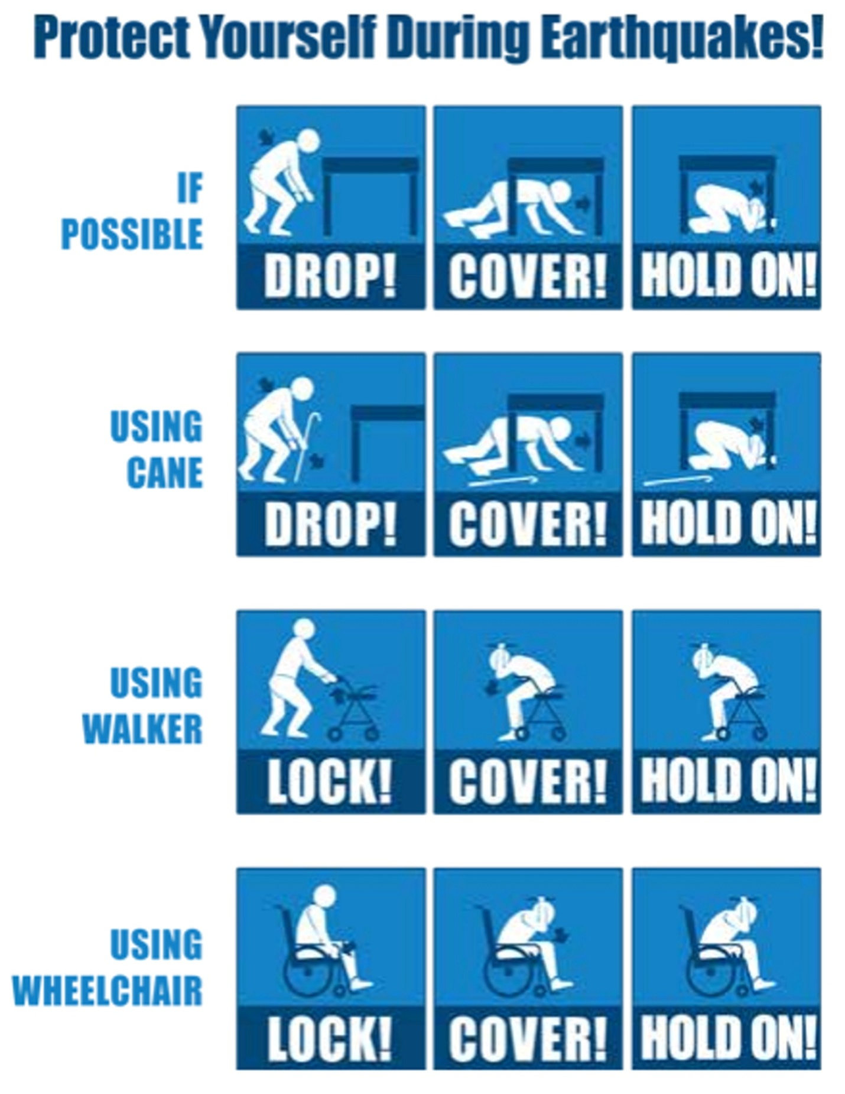

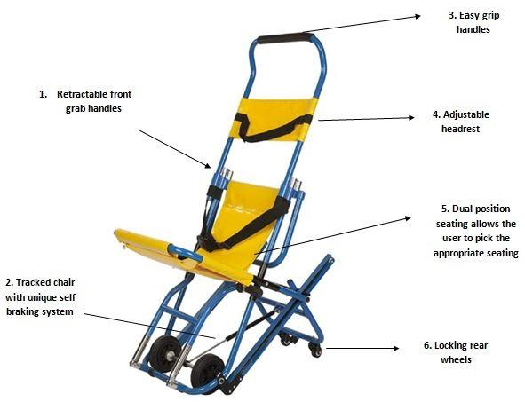
Appendix 3: Examples of Mobility Impaired Emergency Evacuation Equipment

A) Emergency Evacuation Chair
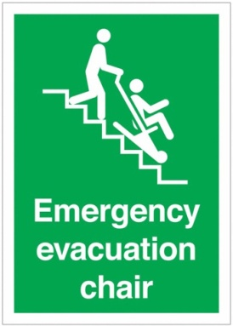

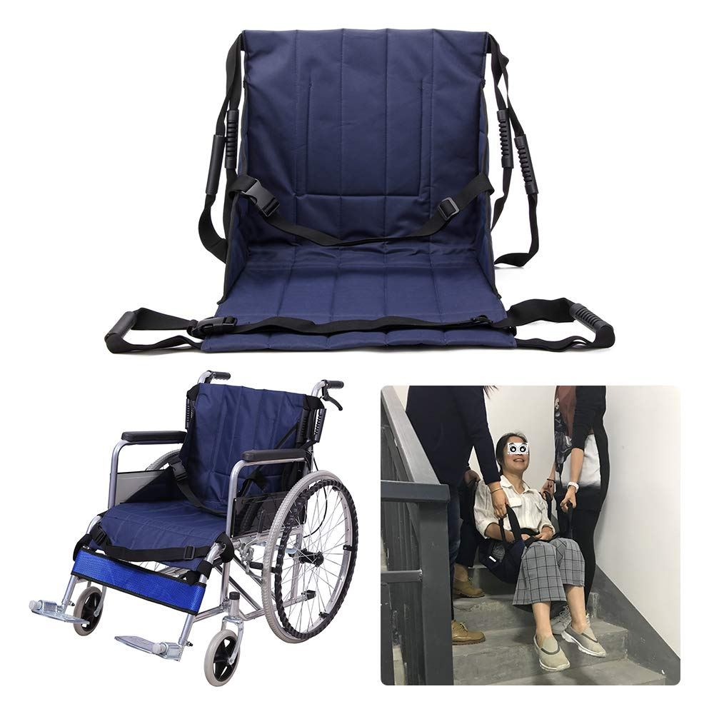

B) Emergency Transfer Unit

Appendix 4: Disaster Preparedness Resources for PWDs
Among the organisations which assist can PWDs to prepare for and respond to disasters are the following:
Organisation | Tel. Number
Dominica Association for Persons with Disabilities (DAPD) | 440 0842
Office of Disaster Management (ODM) | 448 7777
Lifeline Ministries | 449 8595
Village Council (Add Number)*
Local Disaster Committee(Add Number)*
District/Village Health Center (Add Number)*
District/Village Police Station( Add Number)*
District Fire Station (Add Number)*
Community Emergency Response Team - CERT (Add Number)*
Parliamentary Representative (Add Number)*
Community Development Division  (Emergency Shelters, District Development Officer) | 266 3909
Red Cross District Branch (Add Number)*
Dominica - China Friendship Hospital | 266 2000
Police Headquarters | 266 5100
Fire and Ambulance Service (Guard Room, Roseau) | 2664400
Dominica Red Cross Headquarters | 448 8280
Government Headquarters | 266 3000
Faith Based Organisations (Add Numbers)*
(Catholic and Evangelical Churches, Samaritan's Purse, etc.)

Appendix 5: Personal Disaster Planning Information Sheet
